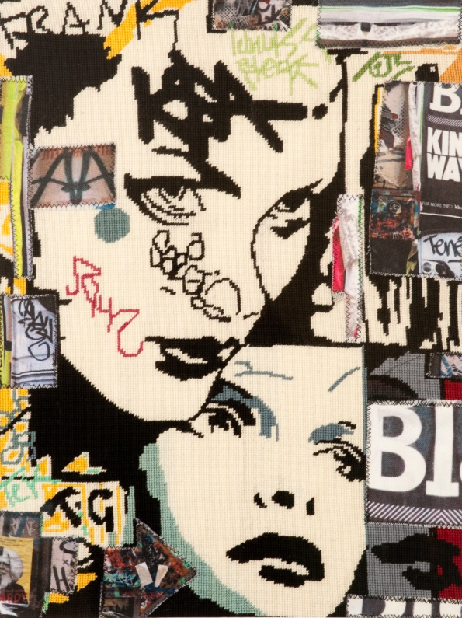
Niki McDonald
The tapestries reflect the design elements from the tagging, graffiti, stencil art and ripped tagged bill posters that are omnipresent in every neighborhood, laneway and city. If there is a blank wall someone will fill it, others will add to it, creating an unorganised collaborative piece of creativity at its rawest. It offers a social commentary of the urban cultures within the community and a feeling of visual claustrophobia that abounds wherever cities form. I use tapestry to represent my images because the repetition of the stitches echo the pixels of digital work and the spray-paint used on the streets. I also love the irony of how street art is so fast, contemporary and masculine and tapestry is so time consuming, traditional and femine.

- Devouring the last – 610 x 460mm - $950
- City Circle – 760 x 460mm - $950
- Soup/coffee – 480 x 640 mm - $850
- In-D-Cent – 500 x 365 mm - $650
- I can’t see you – 450 x 30 mm - $550
- Soup and Coffee – Macro Tapestry - $120
- Arrow – Macro Tapestry -$120
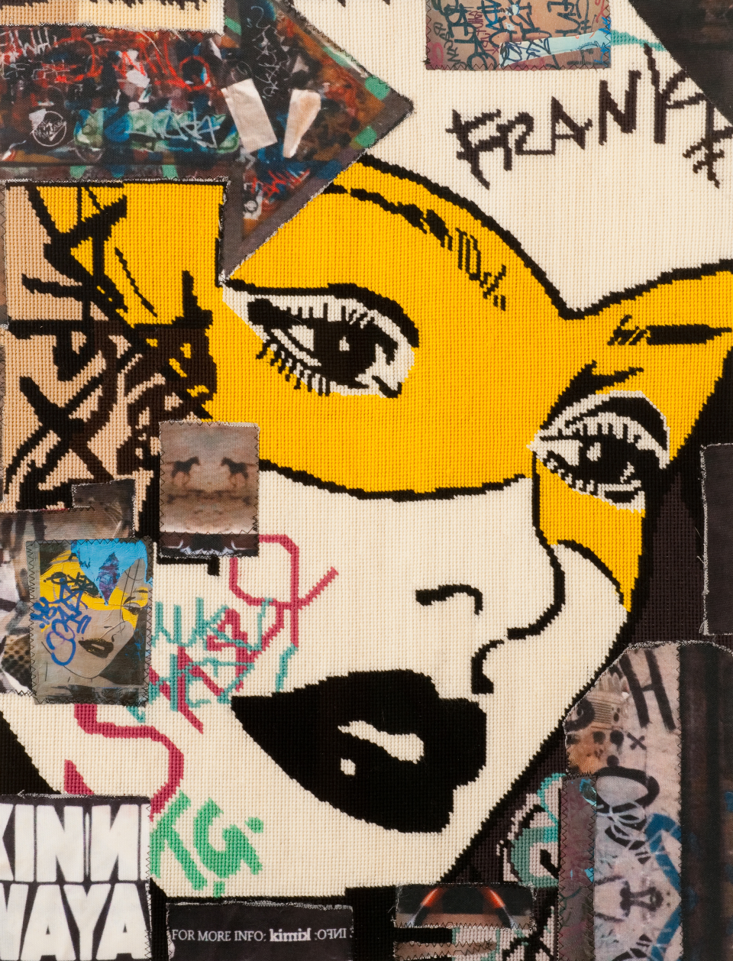
- Walking Home 650 x 480mm - $1300
- Nice Day for a White Washing – 700 x 480mm - $1300
- Frank-ed - (portrait) – 450 x 600mm - $1200
- Frank-ly – (portrait) – 500 x 700mm - $1300
- B-Frank – (portrait) – 450 x 600mm - $1300
It makes up a portion of our landscape; it inspires me so I recreate it. I rely on my art being portable; I draw up my tapestry canvas with a thick black marker, pack the wool and needle in my Tapestry Girl bag and create my artwork where ever I go.

